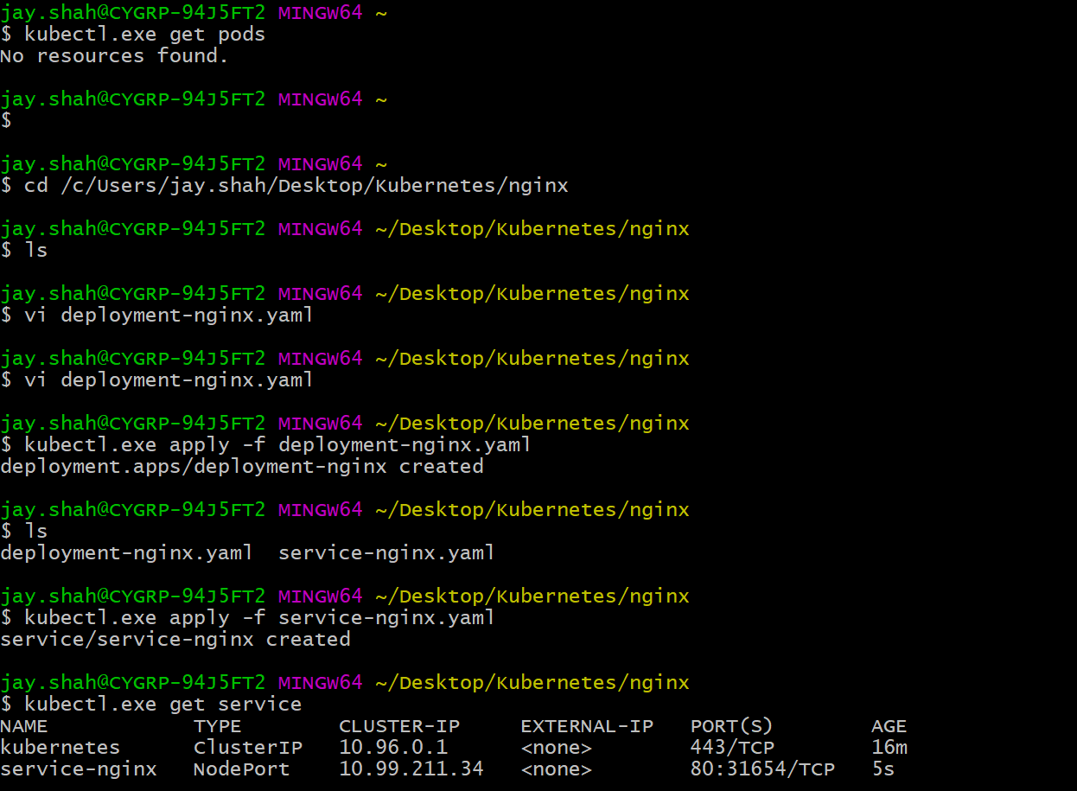

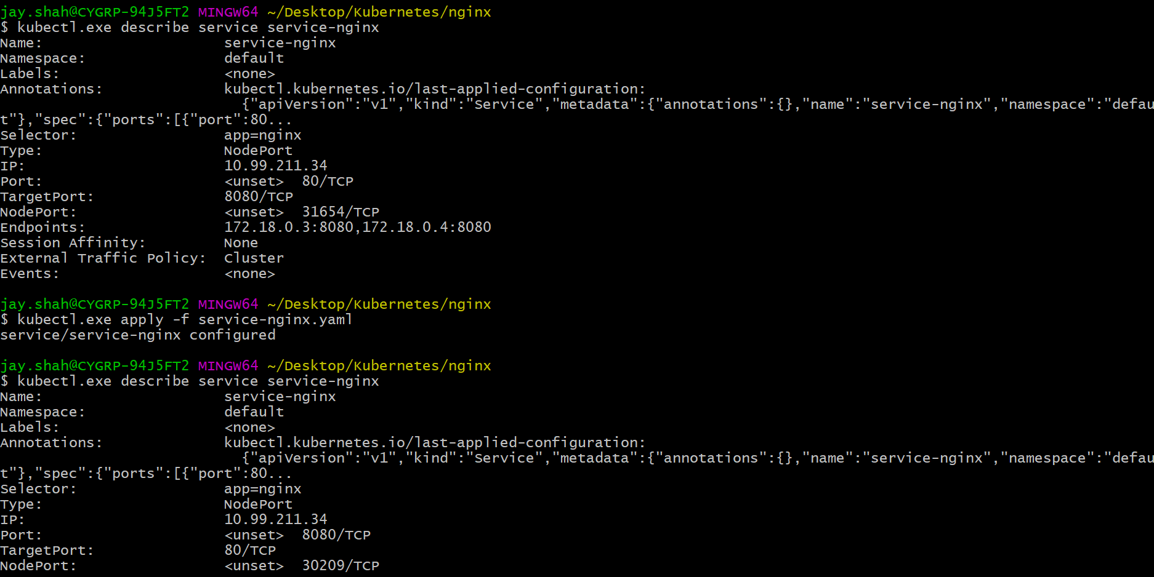

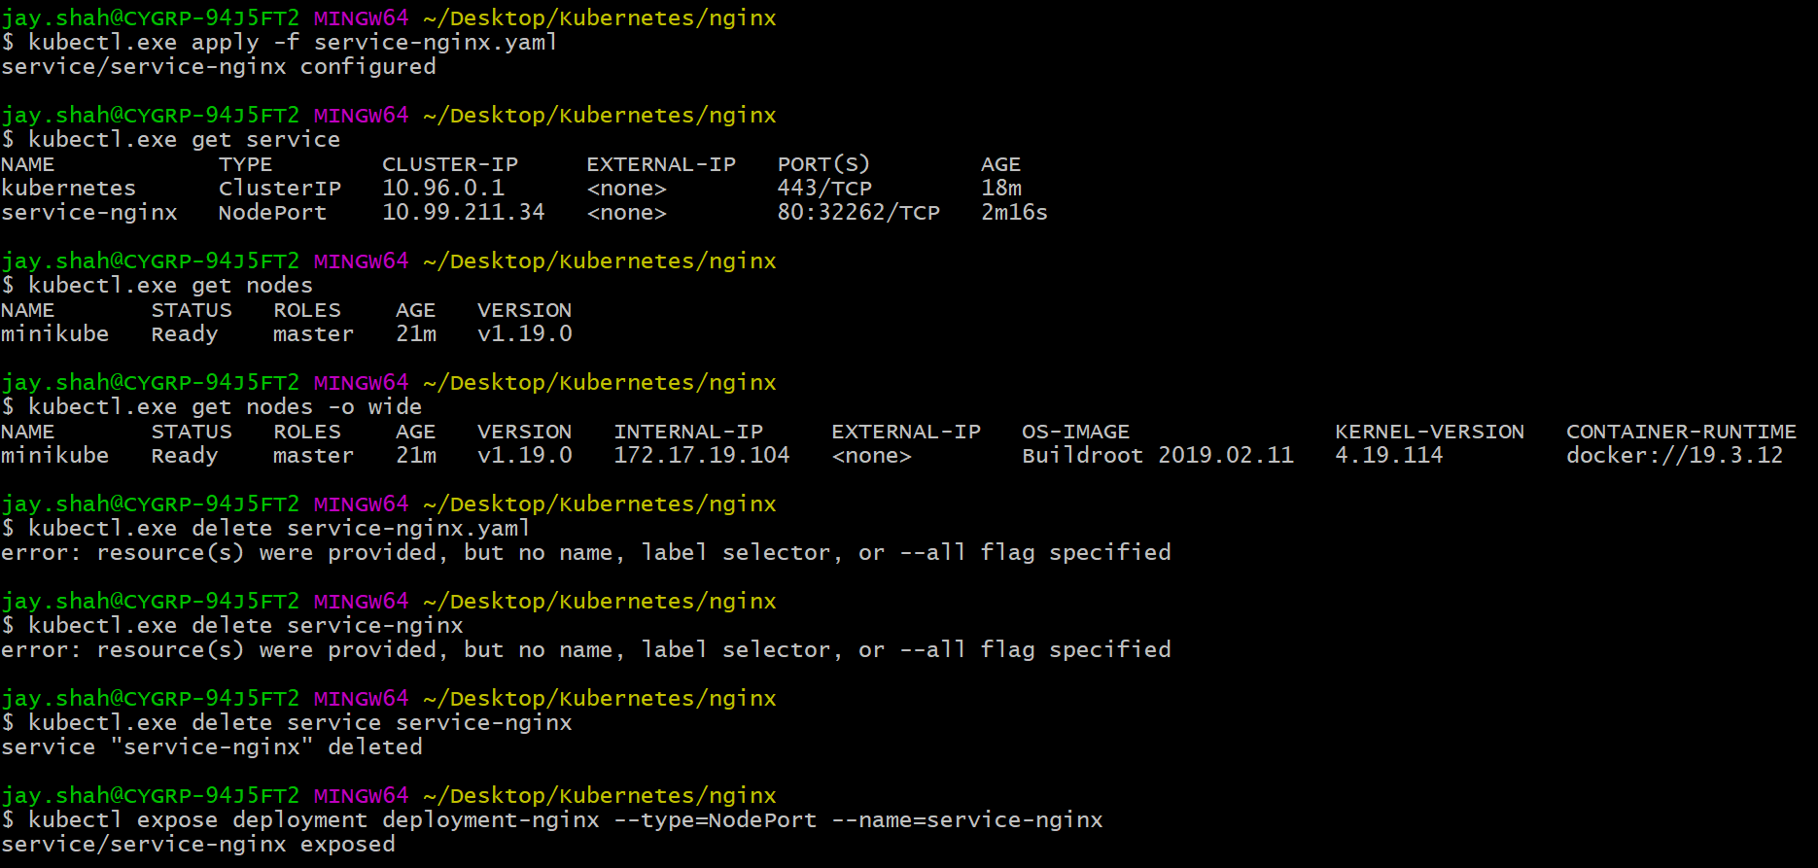

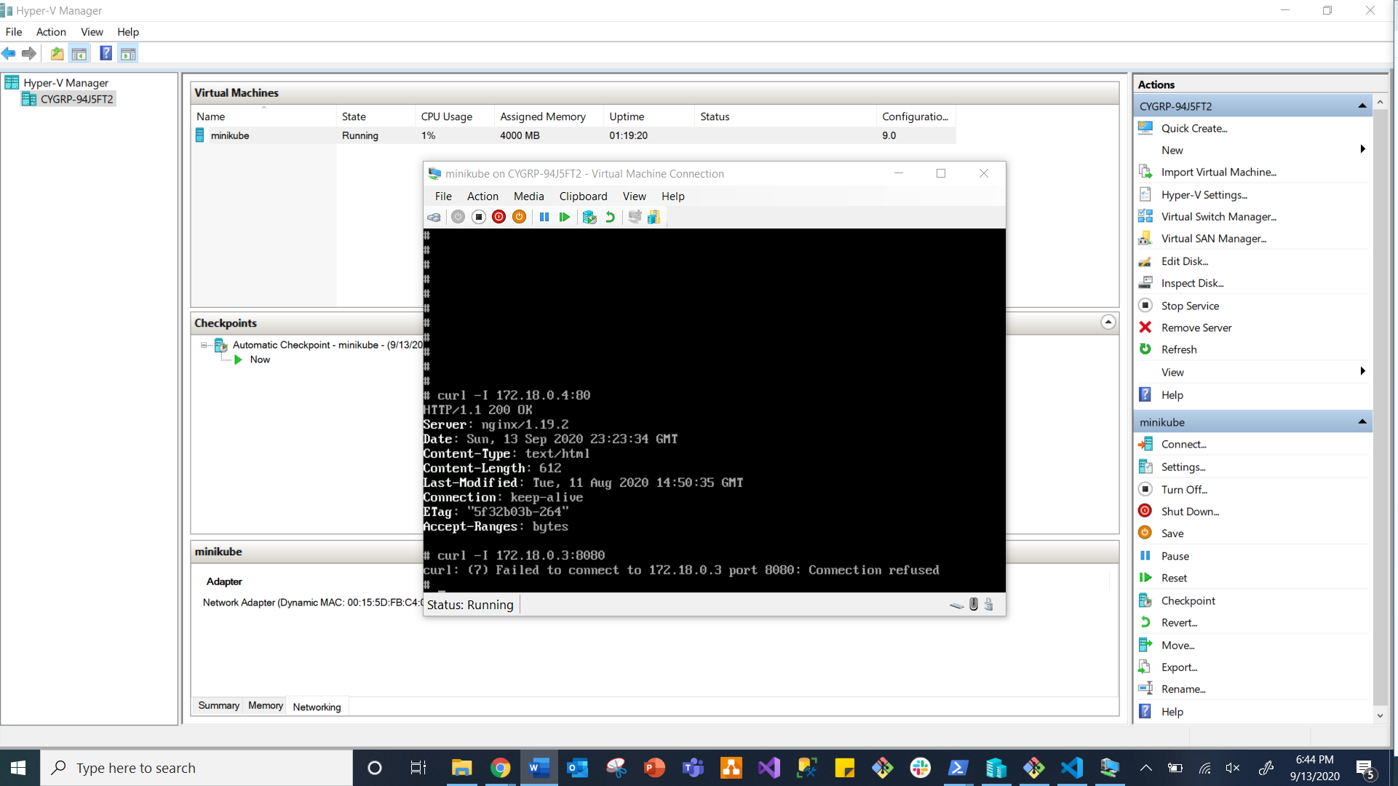

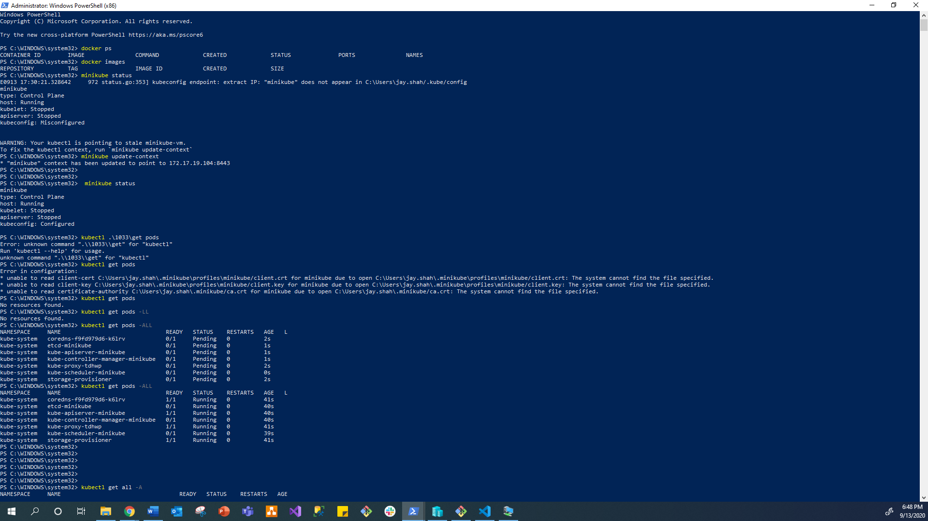

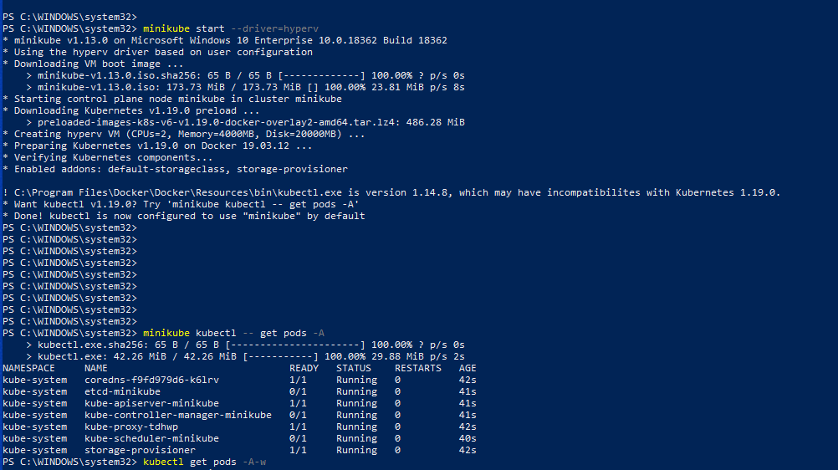

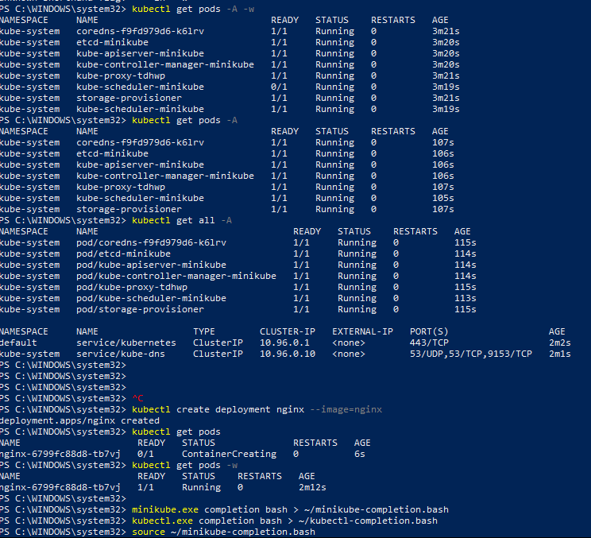

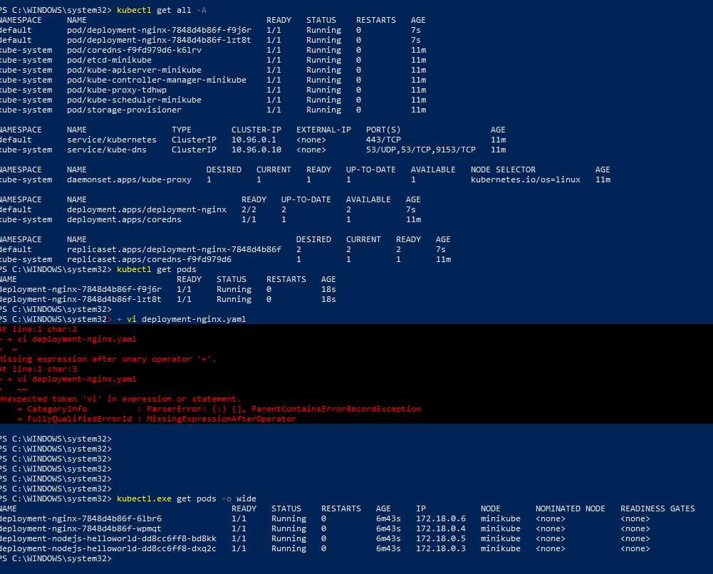

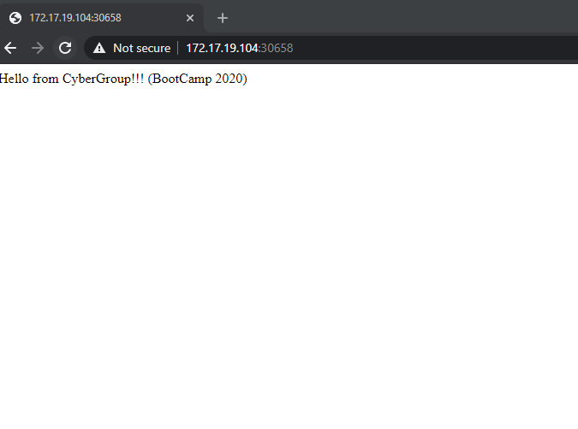

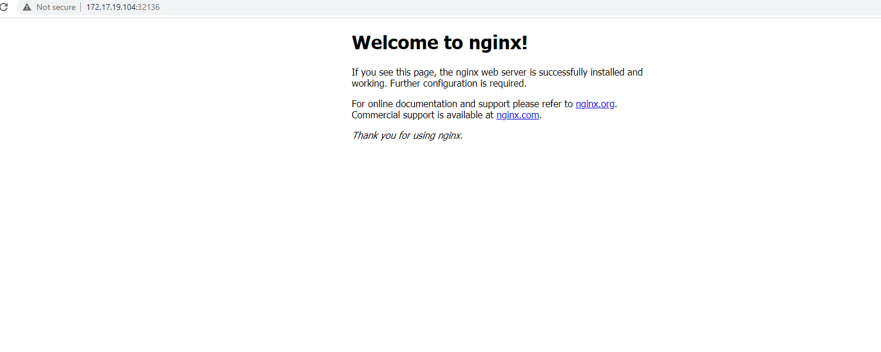

**Bootcamp Tutorial**

Reference materials

1. Use Kubernetes Cheat Sheet for additional commands <https://kubernetes.io/fr/docs/reference/kubectl/cheatsheet/>
2. Intsall MIniKube on local Machine in PowerShell

<https://kubernetes.io/docs/tasks/tools/install-minikube/>

1. Install Command-line tool kubectl

<https://kubernetes.io/docs/tasks/tools/install-kubectl/>

1. Creating a Service file

<https://kubernetes.io/docs/concepts/services-networking/service/#nodeport>

1. Using Service to access an application

<https://kubernetes.io/docs/tasks/access-application-cluster/service-access-application-cluster/>

1. To run deployment

<https://kubernetes.io/docs/tasks/run-application/run-stateless-application-deployment/>

1. Creating a nodes.js web app (Docker Image)

<https://nodejs.org/en/docs/guides/nodejs-docker-webapp/>

1. Installation of node.js

<https://nodejs.org/en/>

Github Commands Used

1 git --version

2 git add

3 git -add

4 git --help

5 kubectl.exe get pods

6 cd /c/Users/jay.shah/Desktop/Kubernetes/nginx

7 ls

8 vi deployment-nginx.yaml

9 vi deployment-nginx.yaml

10 kubectl.exe apply -f deployment-nginx.yaml

11 ls

12 kubectl.exe apply -f service-nginx.yaml

13 kubectl.exe get service

14 kubectl.exe describe service service-nginx

15 kubectl.exe apply -f service-nginx.yaml

16 kubectl.exe describe service service-nginx

17 kubectl.exe apply -f service-nginx.yaml

18 kubectl.exe get service

19 kubectl.exe get nodes

20 kubectl.exe get nodes -o wide

21 kubectl.exe delete service-nginx.yaml

22 kubectl.exe delete service-nginx

23 kubectl.exe delete service service-nginx

24 kubectl expose deployment deployment-nginx --type=NodePort --name=service-nginx

25 kubectl.exe get service

26 kubectl.exe describe service service-nginx

27 kubectl get pods -o wide

28 kubectl.exe get service service-nginx -o yaml

29 kubectl.exe describe service service-nginx

30 kubectl.exe get service

31 kubectl.exe get nodes

32 kubectl.exe get nodes -o wid

33 kubectl.exe get nodes -o wide

34 kubectl.exe apply -f service-nginx.yaml

35 kubectl.exe describe service service-nginx

36 kubectl.exe delete service service-nginx

37 kubectl.exe get service

38 kubectl.exe apply -f service-nginx.yaml

39 kubectl.exe describe service service-nginx

40 kubectl.exe describe service service-nginx | grep -i nodeport

41 kubectl.exe get nodes -o wide

42 docker ps

43 docker run -d -p 8080:8080 jeffbeiercygrp/nodejs-helloworld:latest

44 ls

45 kubectl.exe apply -f deployment-nodejs-helloworld.yaml

46 kubectl.exe get pods

47 kubectl.exe apply -f deployment-nodejs-helloworld.yaml

48 kubectl.exe get pods -w

49 kubectl.exe apply -f service-nodejs-helloworld.yaml

50 kubectl.exe get service

51 kubectl.exe apply -f .

52 kubectl.exe get service

53 kubectl.exe apply -f .

54 kubectl.exe get service

55 kubectl.exe get service

56 kubectl.exe delete -f .

57 kubectl.exe get all

58 kubectl.exe get all

59 kubectl.exe delete service service-deployment-nodejs-helloworld

60 kubectl.exe get all

61 kubectl.exe create -f .

62 kubectl.exe get service

63 kubectl.exe get nodes -o wide

64 kubectl.exe get pods

65 kubectl.exe get pods -o wide

66 curl 172.18.0.5

67 curl 172.18.0.5:8080

68 ifconfig

69 ifpconfig

70 ipconfig

71 npm install

72 cd nodeJS-hello-world/

73 npm install

74 kubectl.exe apply -f

75 cd ..

76 kubectl.exe apply -f deployment-nginx.yaml

77 kubectl.exe get pods

78 kubectl.exe apply -f deployment-nginx.yaml

79 kubectl apply -f deployment-nodejs-helloworld.yaml

80 kubectl get service

81 kubectl apply -f deployment-nodejs-helloworld.yaml

82 kubectl get service

83 kubectl get pod

84 history

PowerShell Commands

PS C:\WINDOWS\system32> history

Id CommandLine

-- -----------

1 Enable-WindowsOptionalFeature -Online -FeatureName Microsoft-Hyper-V -All

2 minikube start --driver=hyperv

3 minikube kubectl -- get pods -A

4 kubectl get pods -A-w

5 kubectl get pods -A -w

6 kubectl get pods -A

7 kubectl get all -A

8 kubectl create deployment nginx --image=nginx

9 kubectl get pods

10 kubectl get pods -w

11 minikube.exe completion bash > ~/minikube-completion.bash

12 kubectl.exe completion bash > ~/kubectl-completion.bash

13 source ~/minikube-completion.bash

14 source ~/kubectl-completion.bash

15 alias minikube='minikube.exe'

16 alias kubectl='kubectl.exe'

17 kubectl.exe delete deployment

18 kubectl.exe get deployment

19 kubectl.exe delete deployment nginx

20 vi deployment-nginx.yaml

21 kubectl get all -A

22 kubectl get pods

23 + vi deployment-nginx.yaml

24 kubectl.exe get pods -o wide

Id CommandLine

-- -----------

1 docker ps

2 docker images

3 minikube status

4 minikube update-context

5 minikube status

6 kubectl .\1033\get pods

7 kubectl get pods

8 kubectl get pods

9 kubectl get pods -LL

10 kubectl get pods -ALL

11 kubectl get pods -ALL

12 kubectl get all -A